1. Project Overview
Field | Details
Project Name | student-records-app
Backend | Node.js (v20-alpine) — Express REST API
Database | PostgreSQL 16 (alpine)
Networking | Docker MacVLAN (student_macvlan)
Orchestration | Docker Compose
API IP Address | 192.168.1.100:3000
DB IP Address | 192.168.1.101:5432

2. Project Structure
The project was initialized with the following directory layout:
student-records-app/
├── backend/
│ ├── Dockerfile
│ ├── index.js
│ ├── package.json
│ └── .dockerignore
├── database/
│ ├── Dockerfile
│ └── init.sql
├── docker-compose.yml
├── network_setup.sh
└── .env

2.1 Setup Commands
The project directory and all required files were created using the following shell commands:
mkdir student-records-app && cd student-records-app
mkdir backend database
touch backend/index.js backend/package.json backend/Dockerfile backend/.dockerignore
touch database/Dockerfile database/init.sql
touch docker-compose.yml
touch network_setup.sh
touch .env
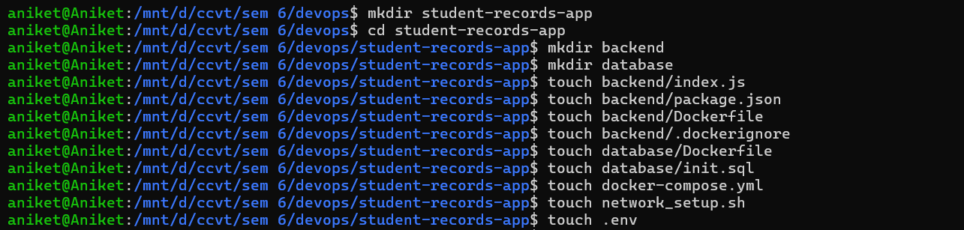

3. Component Descriptions

3.1 Backend (Node.js)
File: backend/index.js
The backend is a Node.js Express application that provides a REST API for student CRUD operations. It connects to the PostgreSQL database using the pg library and initializes the students table on startup.

Endpoint | Description
GET /health | Health check — returns {status: 'ok'}
GET /students | Retrieve all student records
POST /students | Add a new student record

3.2 Backend Dockerfile
The backend uses a multi-stage build for a lean production image:
- Stage 1 (builder): Uses node:20-alpine, installs npm dependencies
- Stage 2 (production): Copies built app, creates a non-root user (appuser) for security
- Exposes port 3000

3.3 Database (PostgreSQL)
File: database/init.sql
A custom PostgreSQL image is built from postgres:16-alpine. The init.sql script is placed in /docker-entrypoint-initdb.d/ so it runs automatically on first container startup. It creates the students table with the schema: id (serial PK), name, roll_number, department, year.

3.4 Docker Compose
File: docker-compose.yml
The Compose file defines two services (backend, database) and one named volume (student_pgdata). Both services are attached to the custom student_macvlan network with static IPs assigned:
- studentapi container → 192.168.1.100
- studentdb container → 192.168.1.101

3.5 Environment Configuration
File: .env
Sensitive configuration (database credentials, connection strings) is stored in .env and referenced by Docker Compose. This keeps secrets out of source code and Dockerfiles.

4. Docker MacVLAN Network Setup
The most significant aspect of this assignment is the use of a MacVLAN Docker network, which allows containers to appear as physical devices on the host network with their own MAC addresses.

4.1 Creating the MacVLAN Network
File: network_setup.sh
The script creates a Docker MacVLAN network using the host's eth0 interface:
docker network create \
--driver macvlan \
--subnet=192.168.1.0/24 \
--gateway=192.168.1.1 \
--ip-range=192.168.1.96/28 \
-o parent=eth0 \
student_macvlan

4.2 Host-Side MacVLAN Interface
To allow the host machine to communicate with containers on the MacVLAN network, a macvlan0 sub-interface is created on the host:
sudo ip link add macvlan0 link eth0 type macvlan mode bridge
sudo ip addr add 192.168.1.99/32 dev macvlan0
sudo ip link set macvlan0 up
sudo ip route add 192.168.1.96/28 dev macvlan0
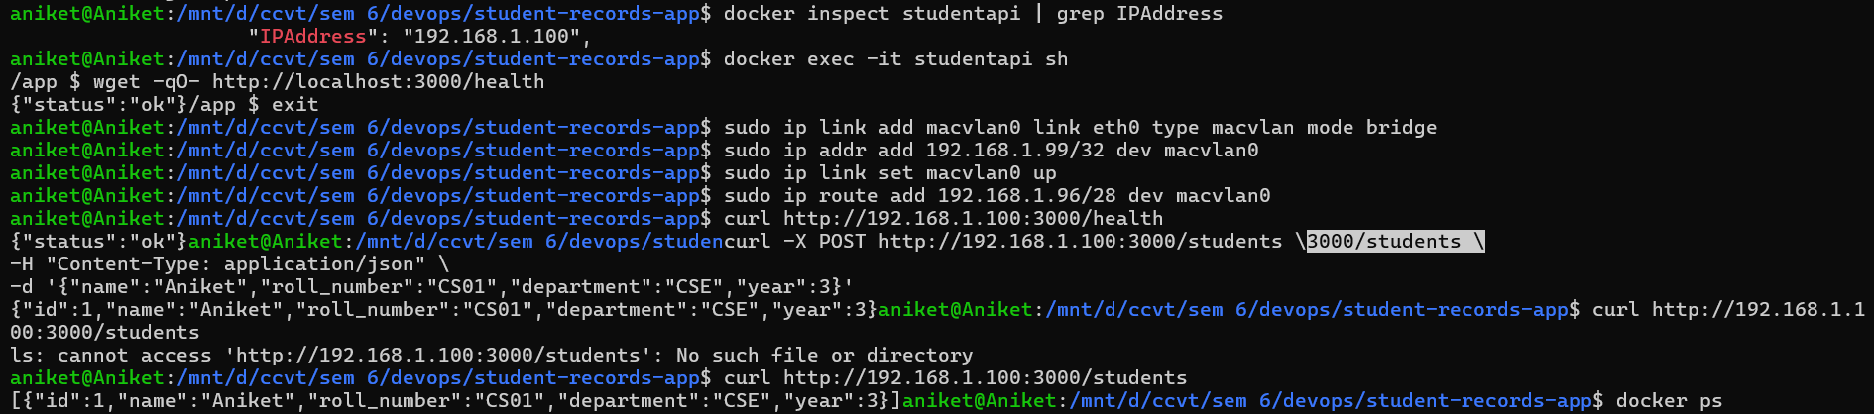

4.3 Network Verification
After setup, the network was verified using docker network inspect student_macvlan, which showed:
- Subnet: 192.168.1.0/24, Gateway: 192.168.1.1
- studentapi assigned MAC 62:aa:32:ba:95:58 at IPv4 192.168.1.100/24
- studentdb assigned MAC 42:e8:53:00:5a:6d at IPv4 192.168.1.101/24

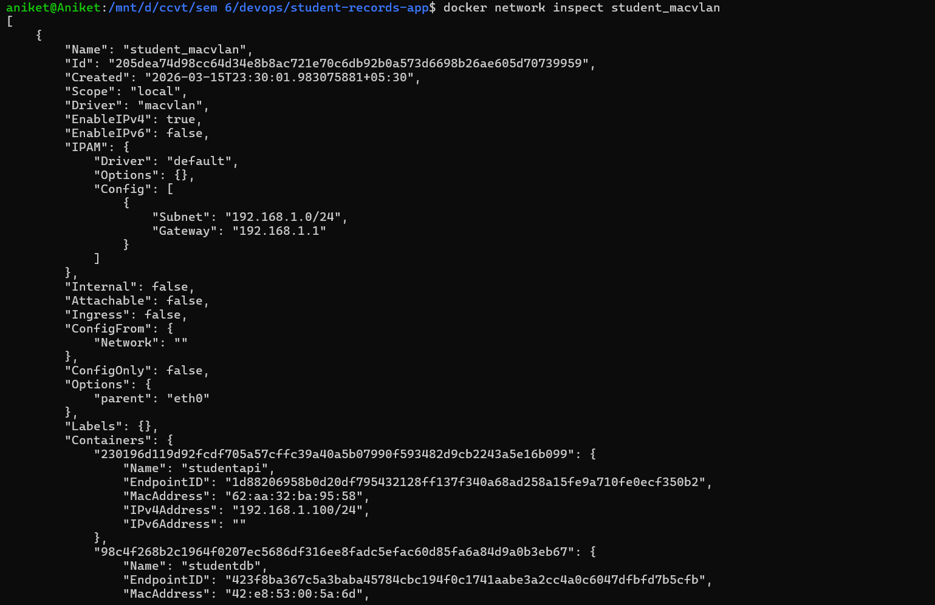

5. Build & Deployment

5.1 Building and Starting Containers
docker compose up --build -d
The build process completed successfully in ~11 seconds:
- student-records-app-backend image built (Node.js multi-stage)
- student-records-app-database image built (PostgreSQL with init.sql)
- Volume student-records-app_student_pgdata created
- Containers studentapi and studentdb started

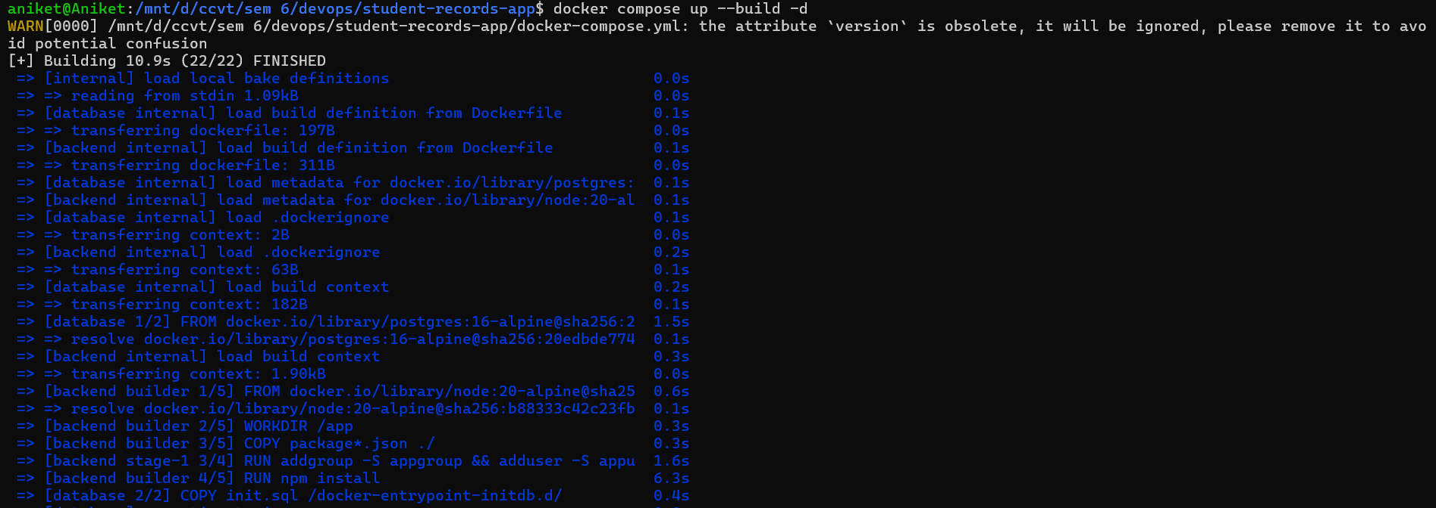
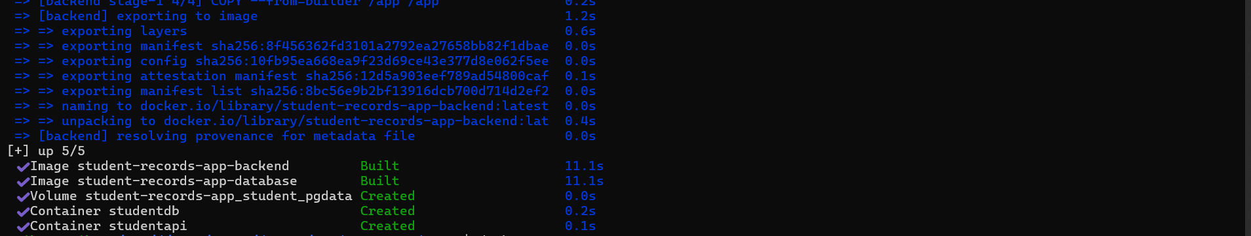

6. Verification & Testing

6.1 Health Check
docker exec -it studentapi sh
wget -qO- http://localhost:3000/health
# Output: {"status":"ok"}

curl http://192.168.1.100:3000/health
# Output: {"status":"ok"}

6.2 Creating Student Records
curl -X POST http://192.168.1.100:3000/students \
-H "Content-Type: application/json" \
-d '{"name":"Aniket","roll_number":"CS01","department":"CSE","year":3}'
# Output: {"id":1,"name":"Aniket","roll_number":"CS01","department":"CSE","year":3}

curl -X POST http://192.168.1.100:3000/students \
-H "Content-Type: application/json" \
-d '{"name":"Rahul","roll_number":"CS02","department":"CSE","year":3}'

6.3 Listing All Students
curl http://192.168.1.100:3000/students
[{"id":1,"name":"Aniket","roll_number":"CS01","department":"CSE","year":3},
{"id":2,"name":"Rahul","roll_number":"CS02","department":"CSE","year":3}]

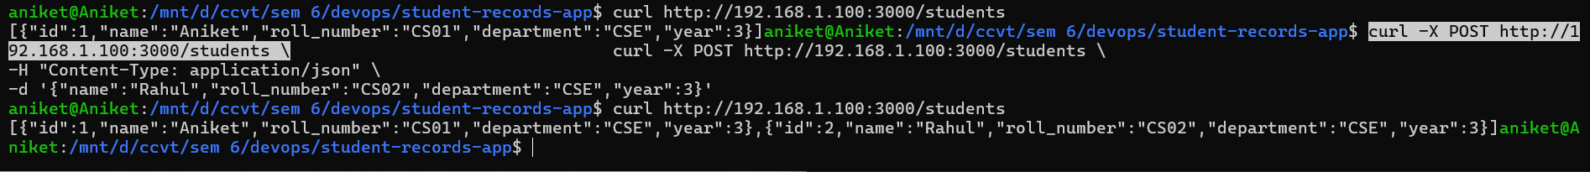

7. Persistent Storage
Data persistence is achieved using a named Docker volume. The volume student-records-app_student_pgdata is managed by Docker Compose and mounts to /var/lib/postgresql/data inside the studentdb container.

Property | Value
Volume Name | student-records-app_student_pgdata
Driver | local
Mount Point | /var/lib/docker/volumes/student-records-app_student_pgdata/_data
Created At | 2026-03-15T23:40:33+05:30
Compose Project | student-records-app
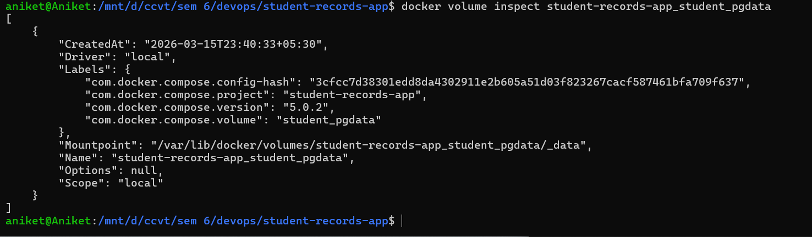

8. Running Containers
The docker ps output showed the following active containers at the time of verification:

Name | Image | Status | Notes
studentapi | student-records-app-backend | Up | REST API — 192.168.1.100:3000
studentdb | student-records-app-database | Up | PostgreSQL — 192.168.1.101:5432

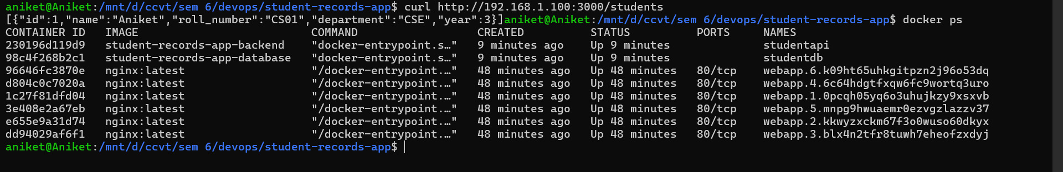

10. Conclusion
The Student Records App was successfully deployed using Docker Compose with a MacVLAN network. Key achievements:
- Containerized a full Node.js + PostgreSQL stack with separate Dockerfiles for each service
- Configured a Docker MacVLAN network (student_macvlan) giving each container a unique IP on the host subnet
- Resolved Docker Hub auth expiry and macvlan host-routing issues during deployment
- Verified REST API endpoints (health check, GET /students, POST /students) via curl
- Confirmed data persistence using a named Docker volume (student_pgdata)

The assignment demonstrates practical experience with containerization, custom networking, multi-service orchestration, and Docker volume management — core DevOps competencies.

